DETAILED DESIGN DOCUMENT: Software Defined Radio Telescope

Phil Behnke
Sean Bredeweg
Dan Soberal

EGR 485

5/26/2011

SECTION 1.0 – INTRODUCTION
The goal this project is to develop a software-defined radio receiver capable of receiving passive radio transmissions from the planet Jupiter. The receiver is intended to be used in conjunction with an antenna provided by the Grand Valley State University physics department for radio astronomy to receive RF radiation from Jupiter. These radio signals are typically carried over a frequency of approximately 20.1 MHz.
The design will be comprised of three main sections. The first of these sections will be the receiver RF Front End. The second section will be the pre-processing section that will handle the conversion of the analog signal to a digital signal and send the data to the PC. The final section is the software front-end, which handles further signal processing of the samples as well as functioning as a user-interface.

SECTION 2.0 – BLOCK DIAGRAM

Receiver
PC running custom DSP software
USB 2.0
Audio output to headphones
Signal from antenna
RF Front End
Pre-processing
Audio converter
Knob to control output volume
Knob to control center frequency
Power Switch

SECTION 3.0 – RF Receiver Front End
There are several specifications to consider for the design of the analog receiver. The first of these is the receiver sensitivity. The receiver sensitivity is the ability of the receiver to receive a weak signal, and is specified as the SNR for analog RF front ends. Also, the sensitivity directly translates to the receiver noise figure. The second specification of interest is the selectivity of the receiver. The selectivity is the ability of the receiver to suppress signals on adjacent channel frequencies, and this determines the parameters of the channel selection filter. The third set of specifications is blocker immunity and intermodulation rejection. Interfering RF signals together with receiver nonlinearities can generate modulation products that fall into the channel of interest. This is generally specified using the Input-Referred Third-Order Intercept Point (IIP3) and 1 dB compression point (P1dB). The block diagram for the receiver is shown in Figure 3.1.
Figure 3.1 – RF Front-End Block Diagram

Section 3.1 – Thermal Noise, Noise Figure, and Noise Factor
Before the sensitivity can be determined, the radio receiver noise floor must first be assessed. To accomplish this, the equivalent input noise for the receiver can be determined using Equation 3.1.1.
$$P_{noise floor }=kTB (3.1.1)$$
In the above equation, k is Boltzmann’s constant (expressed in J/K), B is the bandwidth of the incoming signal in Hz, T is the temperature in Kelvins, and P is the power in W. Without knowing the noise bandwidth of the receiver, and assuming operation at room temperature, this can be calculated as shown in Equation 3.1.2.
$$N_{SA}=4.003×{10}^{-21} B \left[W\right](3.1.2)$$
It is useful in wireless communications and signal processing in general to express power and voltage levels in terms of dB or dBm. The power of the noise available from the antenna can be converted to dBm using the properties of logarithms as shown in Equations 3.1.3 and 3.1.5.
$$N_{SA}=10\log_{10}\left(\frac{4.003×{10}^{-21}B [W]}{{10}^{-3} [W]}\right)(3.1.3)$$
$$N_{SA}=10\log_{10}\left(\frac{4.003×{10}^{-21}}{{10}^{-3}}\right)+10\log_{10}\left(B\right)(3.1.4)$$
$$N_{SA}=-174 +10\log_{10}\left(B\right)\left[dBm\right](3.1.5)$$
According to the sponsor of the project, the antenna bandwidth is approximately 2 MHz. Therefore, the noise power at the receiver is given by Equation 3.1.6.
$$N_{SA}=-174 +10\log_{10}\left(2×{10}^{6}\right)\left[dBm\right]=-111 [dBm] (3.1.5)$$
The actual noise floor of the system is given as Equation 3.1.7.
$$N_{floor}=10\log_{10}\left(kTB\right)+NF=N_{SA}+NF=-111+NF \left[dBm\right](3.1.7)$$
The variable NF in the above equation is the noise figure. From Equation 3.1.7, it is clear that it is desirable to have the noise figure as small as possible, in order to bring the level of the noise floor down as much as possible. The noise figure can be calculated according to Equation 3.1.8.
$$NF=10\log_{10}\left(\frac{N_{SA}+N_{IN}}{N_{SA}}\right)=10\log_{10}\left(1+\frac{N_{IN}}{N_{SA}}\right)\left[dB\right](3.1.8)$$
The quantity inside the logarithm is a commonly used figure of merit for receiver sensitivity, and is called the noise factor (Equation 3.1.9).
$$F=1+\frac{N_{IN}}{N_{SA}} (3.1.9)$$
Now, the input noise energy of the noise receiver must be determined. This figure can also be related to the noise voltage density, which is a very useful metric for picking LNA and filters in receiver design. This is shown in Equation 3.1.10.
$$N_{IN}=\frac{V_{ni}^{2}}{R_{s}}(3.1.10)$$
In this case, V_{ni} is noise voltage density, and is expressed in volts-per-root-hertz.
The noise factor of the system is actually dependent upon the total contributions from each subsystem, according to Friis’ formula, as shown in Equation 3.1.11. Friis’s formula for cascaded stages is derived from Equation 3.1.10, but he noise analysis required for this derivation will not be shown here.
$$F_{N}=F_{1}+\sum_{i=2}^{N-1}{\frac{F_{i}-1}{\prod_{j=1}^{i-1}{G_{j}}}}=F_{1}+\frac{F_{2}-1}{G_{1}}+…+\frac{F_{N-1}-1}{\prod_{j=1}^{N-1}{G_{j}}}(3.1.11)$$
Figure 3.1.1 below shows the noise factor for each stage.
Figure 3.1.1 – Block Diagram with Gains and Noise Factors
In this case the total noise factor of the system is shown in Equation 3.1.12.
$$F_{N}=F_{1}+\frac{F_{2}-1}{G_{1}}+\frac{F_{3}-1}{G_{1}G_{2}}+\frac{F_{4}-1}{G_{1}G_{2}G_{3}}+\frac{F_{5}-1}{G_{1}G_{2}G_{3}G_{4}} (3.1.12)$$
Now, the noise figure of the total system can be considered. The noise figure is the representation of the noise factor in dB, as shown in Equation 3.1.13.
$$NF_{N}=10\log_{10}\left(F_{N}\right) (3.1.13)$$
The noise figures for each component were calculated, and the results are shown in Table 3.1.1.
Table 3.1.1: Noise Figures and Gain at Each Stage
 |  |  | Stage
Parameter | Filter | LNA | GAIN 1 | GAIN 2 | MIXER | Filter | GAIN3
Gain (dB) | 0 | 16 | 19 | 19 | 17 | 0 | 19
NF (dB) | 0.00053 | 3.5 | 4.3 | 4.3 | 5 | 0.00053 | 4.3

Now, Equation 3.1.12 can be applied (however, each noise figure must be converted using the inverse of Equation 3.1.14).
$$F_{N}={10}^{\frac{0.00053}{10}}+\frac{{10}^{\frac{3.5}{10}}-1}{{10}^{\frac{0}{10}}}+\frac{{10}^{\frac{4.3}{10}}-1}{{10}^{\frac{0}{10}}{10}^{\frac{16}{10}}}+\frac{{10}^{\frac{4.3}{10}}-1}{{10}^{\frac{0}{10}}{10}^{\frac{16}{10}}{10}^{\frac{19}{10}}}+\frac{{10}^{\frac{5}{10}}-1}{{10}^{\frac{0}{10}}{10}^{\frac{16}{10}}{10}^{\frac{19}{10}}{10}^{\frac{19}{10}}}≅2.281 (3.1.14)$$
Now, using Equation 3.1.14, this noise factor can be converted back into the noise figure.
$$NF_{N}=10\log_{10}\left(2.2818\right)=3.5828 \left[dB\right] (3.1.15)$$
Finally, we can go back and calculate the noise floor of the system.
$$N_{floor}=-111 dBm+3.5828 dB=-107.4172 \left[dBm\right] (3.1.16)$$

Section 3.2 – Receiver Selectivity and Sensitivity

The minimum discernable signal for the receiver should be 1 µV. This can be translated into a signal power using Equations 3.2.1 through 3.2.4.
$$P_{dBm}=10\log_{10}\left(\frac{\frac{V_{rms}^{2}}{R_{ref}}}{{10}^{-3}}\right)(3.2.1)$$
$$V_{rms}=\frac{V_{peak}}{\sqrt{2}}(3.2.2)$$
$$P_{dBm}=10\log_{10}\left(\frac{V_{Peak}^{2}}{2 R_{ref}×{10}^{-3}}\right)(3.2.3)$$
$$P_{mds}=10\log_{10}\left(\frac{{\left({10}^{-6}\left[V\right]\right)}^{2}}{2\left(50 Ω\right)\left({10}^{-3} [W]\right)}\right)=-110 \left[dBm\right](3.2.4)$$
This is the minimum discernable signal under ideal conditions. The actual minimum signal that can be detected is a function of the noise figure, the bandwidth, and the noise floor of the receiver.
$$MDS\left(dBm\right)= -174+NF_{Rx}+10\log_{10}\left(\frac{B_{IF}}{1 Hz}\right) (3.2.5)$$
In this case, the noise figure would be 3.5828 dB, and the bandwidth would be 2 MHz.
$$MDS\left(dBm\right)= -174+3.5828+10\log_{10}\left(\frac{2×{10}^{6} Hz}{1 Hz}\right)=-110.4069 [dBm] (3.2.6)$$
So, the minimum discernable signal level of the designed system meets the requirement.

Section 3.3 – Receiver Immunity and Rejection

Two important parameters discussed in this section are the 1-dB compression point (P1dB) and the third order intercept point (IIP3). When operating within the linear region of a component, gain through that component is constant for a given frequency. As the input signal is increased in power, a point is reached where the power of the signal at the output is not amplified by the same amount as the smaller signal. At the point where the input signal is amplified by an amount 1 dB less than the small signal gain, the 1 dB Compression Point has been reached. A rapid decrease in gain will be experienced after the 1 dB compression point is reached. If the input power is increased to an extreme value, the component will be destroyed. Therefore, it is desirable to have components with very high 1 dB compression points.
Like noise factors, 1-dB compression points can be calculated for cascaded inputs, as shown in Equation 3.3.1.
$$P_{1dB,N}=10\log_{10}\left(\frac{1}{p_{1dB,N-1}g_{N}}+\frac{1}{p_{1dB,N}}\right)(3.3.1)$$
Next, the third order intercept point can be considered. The third-order intercept point is the theoretical point on the RF vs. IF output curve where the desired input signal and third order products become equal in amplitude as the RF input is raised. So, it is useful as a figure of merit for linearity or distortion. Again, a formula similar to Friis’ equation can be used to model this parameter for cascaded components, and this is shown in Equation 3.3.2.
$$IIP3=\frac{1}{IIP3_{1}}+\frac{G_{1}}{IIP3_{2}}+\frac{G_{1}G_{2}}{IIP3_{3}}+…+\frac{\prod_{j=1}^{n-1}{G_{j}}}{IIP_{n}}=\sum_{i=1}^{N}{\frac{\prod_{j=1}^{i-1}{G_{j}}}{IIP3_{i}}} (3.3.2)$$
In datasheets for most RF components, the output referred third order intercept point is given. The input-referred third order intercept point can be calculated from the output third order intercept point and the gain. This is shown in Equation 3.3.3.
$$IIP_{3}=OIP_{3}-G \left[dBm\right] (3.3.3)$$
Thus, Equation 3.3.2 can be rewritten as Equation 3.3.4 to accommodate Equation 3.3.3.
$$IIP3=\frac{1}{OIP3_{1}/G_{1}}+\frac{G_{1}}{OIP3_{2}/G_{2}}+\frac{G_{1}G_{2}}{OIP3_{3}/G_{3}}+…=\sum_{i=1}^{N}{\frac{\prod_{j=1}^{i}{G_{j}}}{OIP3_{i}}} (3.3.4)$$
As a side note, the IIP₃ in the above equation is not in dB. This is why the input referred third order intercept point is equal to the output point divided by the gain (this was derived using properties of logarithms in the plane of real numbers). Also, note that the end index for the product in Equation 3.3.4 changed from i-1 to i because of the division by the (i-1)^{th} gain.
These two parameters are useful for verifying the spurious-free dynamic range of the receiver (SFDR). This equation is shown as Equation 3.3.4.
$$SFDR=\frac{2\left(P_{IIP3}-F\right)}{3}-SNR_{min}=\frac{2}{3}\left(P_{IIP3}-P_{noise floor}\right) (3.3.4)$$
The gain at each stage is summarized in Table 3.3.1.
Table 3.3.1: System Parameters
 |  |  | Stage
Parameter | Filter | LNA | GAIN 1 | GAIN 2 | MIXER | Filter | GAIN 3
Gain (dB) | 0 | 16 | 19 | 19 | 17 | 0 | 19
NF (dB) | 0.00053 | 3.5 | 4.3 | 4.3 | 5 | 0.00053 | 4.3
IP3 (dBm) | Inf | 13 | 13 | 13 | -13 | Inf | 13
P1dB (dBm) | Inf | 2.9 | 22 | 22 | NA | Inf | 22

Using these figures, the final dynamic range was calculated to be 88 dB with the mixer taken out of the receiver path, and 52 dB with the mixer in the path. These calculations are performed using the MATLAB code shown in Appendix C, Figure C.4.

SECTION 4.0 –RF HARDWARE

Section 4.1 – Inductor Selection

At 20.1 MHz, the parasitic properties of passive components become important. A model of one of the inductors used in the design with parasitic elements included is shown in Figure 4.1.1.
Figure 4.1.1: Inductor Model
Some important properties that arise because of this model are self-resonant frequency, Q factor, and equivalent series resistance (ESR). When choosing an inductor or RF choke for a design, it is important keep the ESR as low as possible (generally in range of hundreds of mΩ). Furthermore, the self-resonant frequency (SRF) should be much greater than the operating frequency (as a general rule, a factor of 10 above the operating frequency). At the self-resonant frequency, the current through the inductor will peak sharply, and the excessive current draw can damage the inductor. Finally, there is the quality factor (Q). The quality factor determines how well an inductor behaves like an ideal inductor at a certain frequency. Therefore, a high Q factor at the operating frequency is essential for inductors.
Also, there are material properties to consider for inductors. Typical RF inductors and chokes come in four general forms: air core, powdered iron, ferrite core, and toroid core. For this project, ferrite core inductors were used. Table 4.1.1 shows some different ferrite core materials and summarizes their uses.
Table 4.1.1: Ferrite Materials
The materials used in the inductors chosen were chosen to maximize Q and SRF while minimizing ESR. Coilcraft inductors were used almost exclusively in the project, as they provide easy Spice models of their inductors and list all the necessary material properties for each inductor they make.

Section 4.2 – Capacitor Selection

Like inductors, capacitors also have parasitic properties to be considered. Figure 4.2.1 shows a model of a capacitor with included parasitic effects.
Figure 4.2.1 – Capacitor with Parasitics
Capacitors also have similar properties that become important at high frequencies that inductors have. When selecting capacitors, SRF, ESL, SRF, and Q factor are important. Typically, low ESL and ESR, high Q capacitors are chosen, and as always, the SRF is chosen to be much higher than the operating frequency. The temperature coefficient of the capacitor is also very important in tuned circuits, as temperature drift can cause unacceptable capacitance variations in some cases. Ceramic capacitors generally have low ESR and ESL. However, their temperature coefficients are generally high. NP0 type capacitors were used in this design as much as possible on the RF front end. NP0 caps have excellent temperature coefficients, and have low ESR and ESL (and thus high linearity). However, the disadvantage of NP0 capacitors is that they can be quite large for sufficiently large capacitance values. For this design X5R and NP0 capacitors were typically chosen.

Section 4.3 – Resistor Selection

For a resistor, the biggest concern is how much thermal noise it introduces into a system. A model of a resistor with noise source is shown in Figure 4.3.1.
Figure 4.3.1 – Noisy Resistor
The voltage magnitude of the thermal noise generated by a resistor can be modeled using Equation 4.3.1.
$$v_{n}=\sqrt{4kTRB} (4.3.1)$$
Clearly, the material used for the resistor does not strictly matter, except in the sense of how its resistivity changes with temperature. Furthermore, it is clear that a high resistance value will yield more thermal noise. Therefore, all resistance values used in the RF front end were kept as small as possible.

Section 4.4 – Bandpass Filter

A third order bandpass filter was used to filter out unwanted parts of the incoming spectrum. The basic circuit is shown below in Figure 4.4.1.

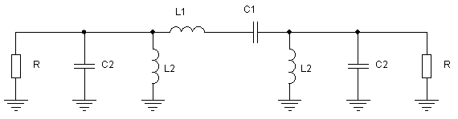
Figure 4.4.1 – Bandpass Filter
The circuit was designed to have a bandwidth of 4 MHz, a high quality factor, a gain of 0 dB, and a center frequency of 20 MHz. The component values for the filter are shown in Table 4.4.1.
Table 4.4.1 – Component Selection
Component | Value
L1 | 3.97 µH
L2 | 80 nH
C1 | 16 pF
C2 | 796 pF

The circuit was simulated in LTspice with parasitic properties integrated into the inductor model. The circuit is shown in Figure 4.4.2.
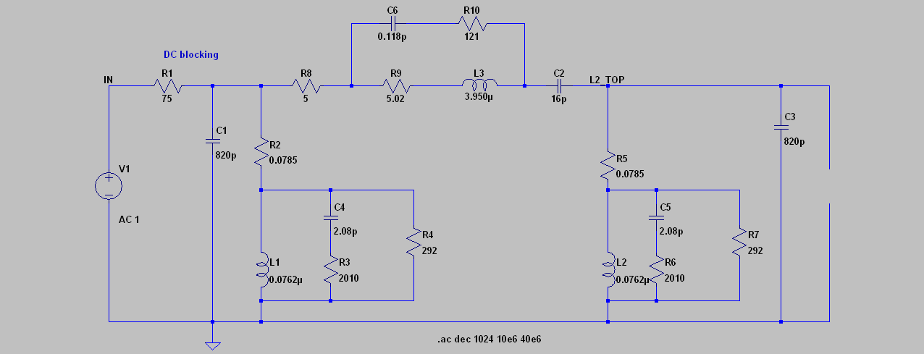
Figure 4.4.2 – LTSpice Simulation Circuit
The frequency response of the circuit was simulated in LTspice, and the resulting Bode plot is shown in Figure 4.4.3.
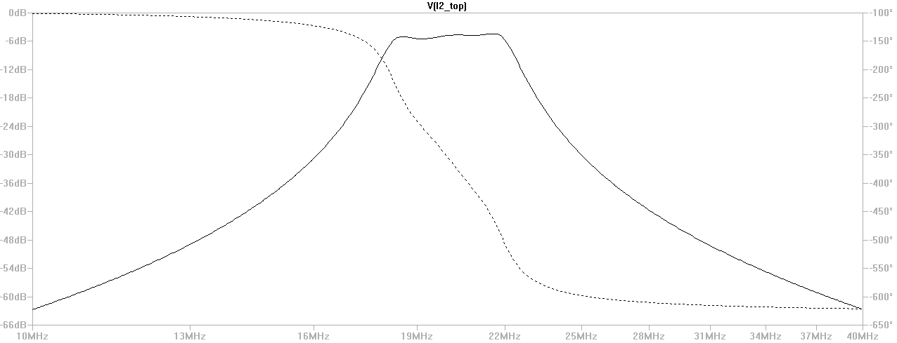
Figure 4.4.3 – Bode Plot of Filter Response
The circuit is designed for unity gain. However, due to component losses, it actually attenuates the signal by 5 dB at its peak.
The noise voltage density of the circuit was also simulated in LTspice, and is shown in Figure 4.4.4.
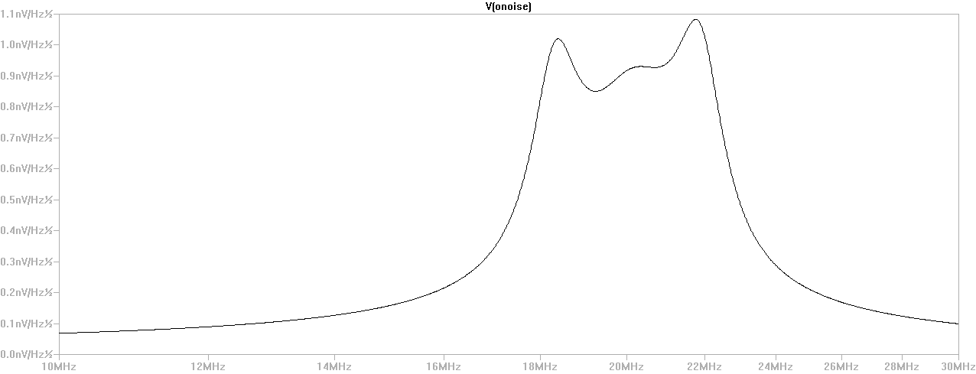
Figure 4.4.4 – Noise Voltage Density at Filter Output
The noise voltage density is 950 pV/Hz^{1/2} at 20.1 MHz. When this noise voltage density is integrated across the band of 16 MHz to 24 MHz, the net result is:
$$v_{n}=\int_{f_{1}}^{f_{2}}{S_{n}^{2} df}=2.1559µV$$
The output impedance of the circuit was also measured using a Thevenin circuit. The output current at an approximate short, and the output voltage at an open circuit were measured at 20.1 MHz. This resistance was found to be approximately 50 Ohms.
The anti-aliasing filter was designed in a similar manner. The anti-aliasing filter was designed as a fourth order butterworth filter, with a mesh-capacitor coupled topology. The circuit is shown in Figure 4.4.5.
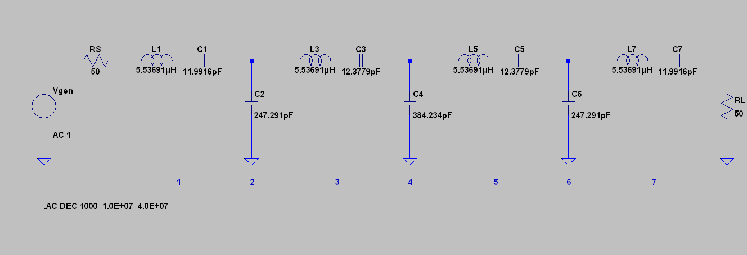
Figure 4.4.5: Bandpass Anti-Aliasing Filter
The circuit was designed for a bandwidth of 1.1 MHz, centered at 20 MHz. The input and output impedance of the circuit are approximately 50 Ohms in the passband. The circuit was modeled with parasitic values of included, and the resulting frequency response of the filter is shown in Figure 4.4.6.
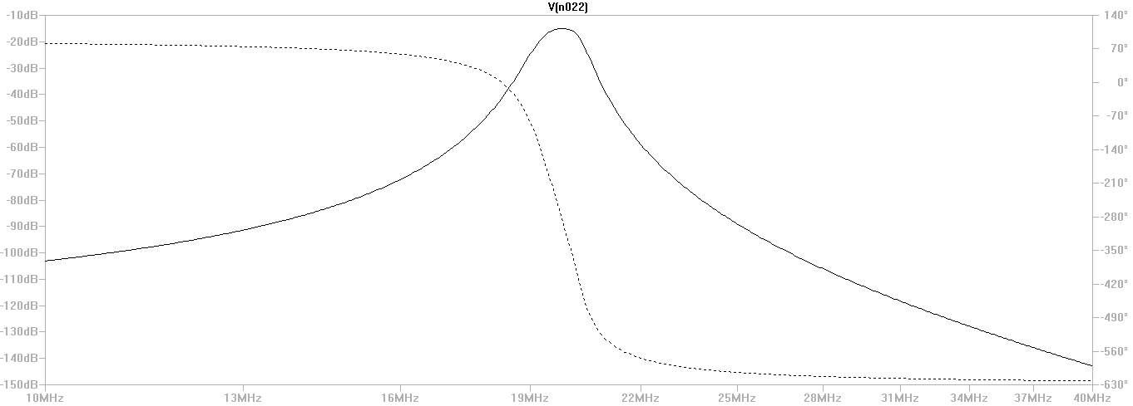
Figure 4.4.6: Frequency Response of Filter
The end result is that the combination of the two filters will attenuate the signal in the passband by approximately 18 dB, and will attenuate any signal at 0 dBm or less to the noise floor within the stopband between 15 MHz and 25 MHz.

Section 4.5 – Low Noise Amplifier

A few different designs were prototyped for the low noise amplifier stage of the design. However, the two most crucial designs were what were dubbed the “J310” design and the “MAX2611” design.
The J310 is a GaAs JFET specifically designed for higher frequency applications. It is used in the Radio Jove receiver as their LNA. The J310 design prototyped for this project was used in the common gate configuration, as shown in Figure 4.5.1.
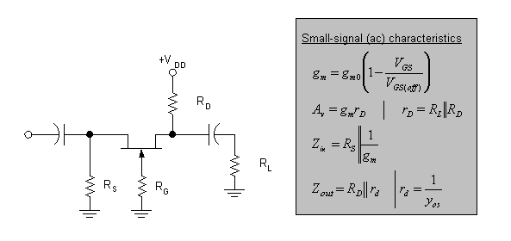
Figure 4.5.1 – Common Gate Amplifier Configuration
The circuit in Figure 4.5.1 was slightly modified to take into account higher frequency effects. RF choke inductors were added to the bias resistor paths, thus separating high frequency content from the power and ground lines in the circuit. Also, a pi-attenuator network was added to match the output impedance of the circuit to 50 Ohms. This is shown in Figure 4.5.2.
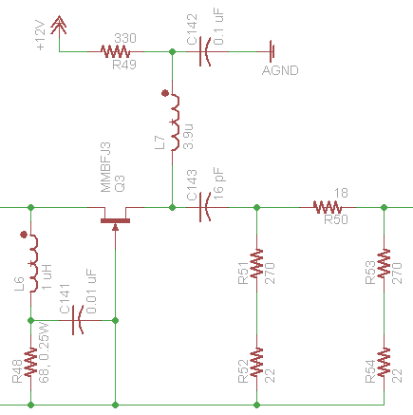
Figure 4.5.2 – Modified Common Gate Amplifier
This design yields a gain of 9 dB, a noise figure of 3.2 dB, a third order intercept point of -2.25 dBm, and an SFDR of 88 dB at an input bandwidth of 2 MHz.
This design is sufficient, and again is very similar to what the Radio Jove (which has been verified to work) uses. However, it has very little gain and a third order intercept point that could limit the net dynamic range at the end of the system (since it is negative). The MAX2611 is an integrated circuit alternative with a higher 1 dB compression point and third order intercept point. The IC has a slightly higher noise figure, but not high enough to be detrimental to the overall system performance. The circuit is shown in Figure 4.5.3.
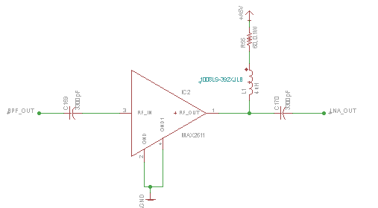
Figure 4.5.3 - MAX2611 LNA Circuit
A model for the MAX2611 was constructed in LTspice, and its frequency response was measured. The LTspice simulation circuit is shown in Figure 4.5.4, and the resulting Bode Plot is shown in Figure 4.5.5.
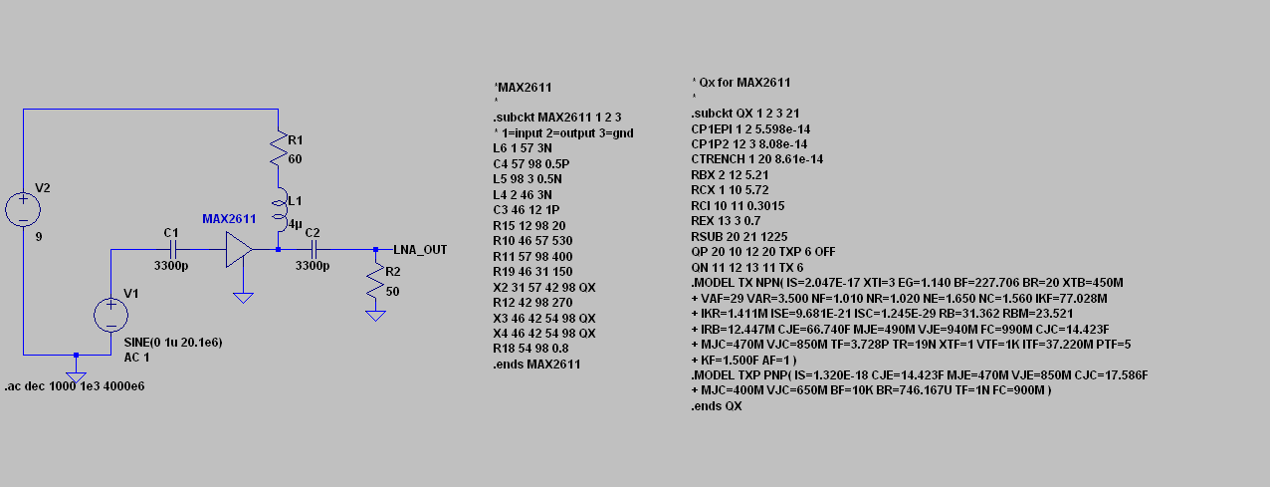
Figure 4.5.4 – MAX2611 Simulation Circuit
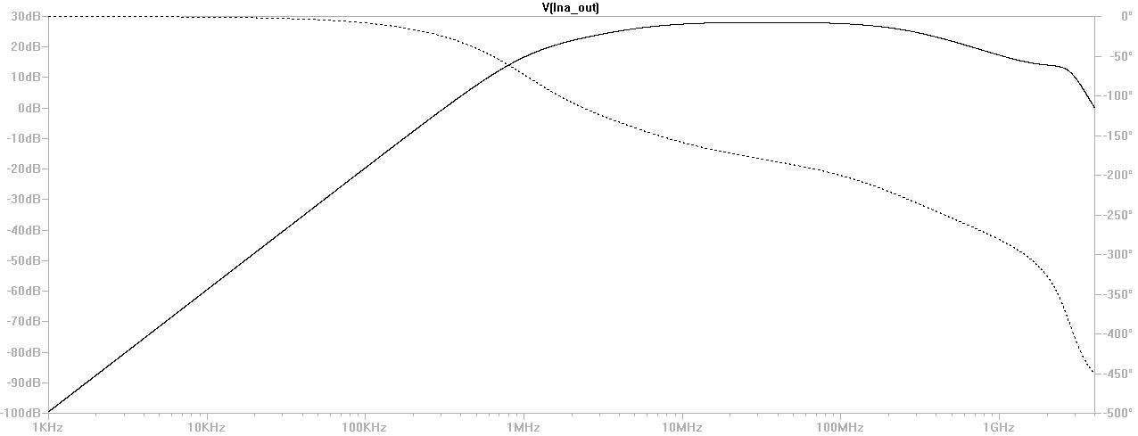
Figure 4.5.5 – Bode Plot of MAX2611 Response

Section 4.6 – Intermediate Gain

There will be two intermediate gain stages in order to increase the gain of the signal by 46 db (aggregate). The IF gain block amplifier chosen was the RF2312 from RF micro devices, and its application circuit is shown in Figure 4.6.1.
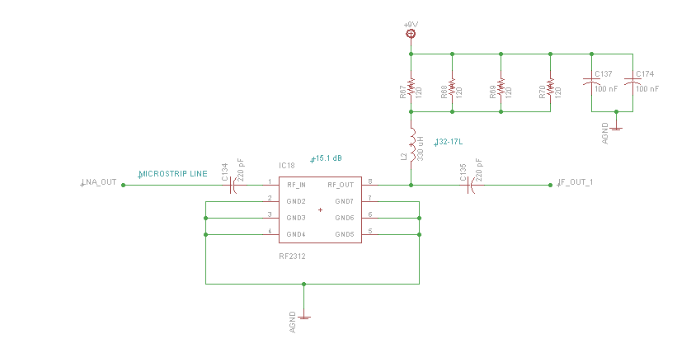
Figure 4.6.1 – IF Gain Block Circuit
With this circuit, the gain of the system is 15.1 dB, the noise Figure is 3.8 dB, and the output IP₃ is 42 dBm. This high output IP₃ helps to increase the net dynamic range considerably, while contributing little to the net noise floor.

SECTION 4.6 – MIXER

The mixer chosen for the direct conversion to audio is the SA612. The circuit for this mixer is shown in Figure 4.6.1.
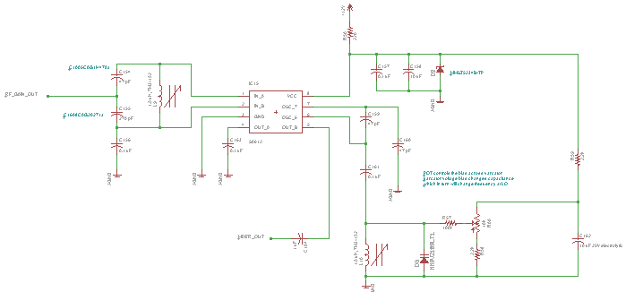
Figure 4.6.1 – Mixer Schematic
This sub-circuit is probably the most complicated part of the analog front-end design. The basic design involves converting the single ended output of the RF gain block into a differential input through the LC circuit at the input of the mixer stage. The signal is mixed with an oscillating signal generated from the LC resonating circuit at the oscillator pins, and the frequency can be controlled through the capacitance of the resonator. This capacitance is controlled by the potentiometer, which changes the bias voltage on the varactor which in turn changes the junction capacitance. The output signal from the mixer is then sent through a supplementary buffer and a low pass filter centered around 15 kHz. The mixer has a noise figure of 1.3 dB, however, its output IP₃ is very low (-13 dBm). This negative output IP₃ would severely degrade the dynamic range of the system. There is a solution to this unwelcome result, however. The entire point of the mixer is to mix a test signal down to audio frequencies for system testing. Therefore, the mixing and audio output circuit would be made into a separate board that can be connected to the overall system during testing, and removed during actual operation. In this way, it would not degrade system performance during actual operation.

SECTION 5.0 – ANALOG/DIGITAL CONVERSION THEORY

The analog digital converter (ADC) is an important part of the system. The ADC has to convert the analog input signal into a digital signal that can be processed by the PC software. The ADC accomplishes this by sampling the incoming continuous analog signal into a discrete digital signal. The sampling rate of the ADC must be chosen so that it is high enough to sample the sinusoidal waves that will be coming through the input. The whole process can therefore be modeled by multiplying the incoming signal with the comb function.
$$x\left(nT_{s}\right)=x[n]=x(t)\sum_{n=-∞}^{∞}{δ\left(t-nT_{s}\right)}$$
When the frequency content of this signal is considered, it is helpful to recall the convolution-multiplication duality property of the Fourier transform. That is, multiplication operations in the time domain yield convolution operations in the frequency domain (and vice-versa). The Fourier transform of the comb function is essentially itself. Therefore, in the frequency domain, the sampled signal is the convolution of the spectrum of the original signal and the impulse train (comb function). Therefore, there will be spectral copies of the original spectrum at every integer multiple of the sampling frequency. This is illustrated in Figure 5.01.
Figure 5.0.1: Spectrum of a Sampled Baseband Signal
If the signal is sampled too slowly, aliasing will occur. When aliasing occurs, the spectral copies of the sampled signal bleed into each other, thus making it impossible to reconstruct the signal later. The Nyquist Theorem can be used to determine how fast the signal should be sampled to avoid this. The Nyquist Theorem states that the sampling frequency should be at least twice as high as the highest frequency that the signal contains.
Often, it is sufficient to sample at exactly twice the highest frequency contained in the baseband signal. However, with sinusoids, some issues occur when this is attempted. Sine functions have the same value when they are sampled at the start of their period, halfway through their period, and at the end of their period. In order to capture a representative sample of the behavior of a sine wave, a higher sampling rate must be used. A sampling rate of 8 or 16 times the highest frequency would yield a more accurate representation.
In order to detect microvolt level signals, the ADC must also have a very high resolution. Ideal y, there should be enough quantization levels to allow for good distinction between incoming voltage levels. The resolution is largely determined by the number of bits the ADC is designed for, the analog input voltage swing the ADC is designed for, and total amount of noise introduced into the system. The resolution of an ideal ADC can be calculated by dividing the analog input voltage swing by the total number of quantization levels.
$$number of quantization levels=2^{N} where N=number of bits$$
$$Voltage Resolution=\frac{{V_{RefHi}-V}_{RefLow}}{Quantization}$$
An ideal 16-bit ADC would give has 65536 quantization levels. Using the equation for voltage resolution, given 2.0V analog input voltage swing, a 16-bit ADC would have a voltage resolution of 30.51 μV. This figure is a good reference point but does not accurately reflect the devices performance actual performance. In the sections following, a brief description of ADC performance and sources of ADC error will be introduced to help explain why we cannot base our design decisions on the ideal ADC model.

SECTION 5.1 - ANALOG/ DIGITAL PERFORMANCE

Spurious Free Dynamic Range
Perhaps the best measure of an ADC's in-band distortion performance is its spurious free dynamic range. The SFDR is the difference in amplitude of the desired signal to amplitude of the highest spurious signal in the band of interest. An analog to digital converter with a large SFDR means that it is able to process low level signals in the presence of higher power ones. The spurious free dynamic range is generally plotted as a function of signal amplitude and may be expressed relative to the signal amplitude (dBc) or the ADC’s full-scale analog input (dBFS) as shown in Figure 5.1.1.
In testing and determining the devices performance, the desired signal may be single or multi-tone. A multi-tone signal can excite intermodulation (IM) products. Intermodulation products, which will be described in more detail later, are distortions that occur not only at integer values of each of the tones present in the signal but also at the sum and differences as well. The signals in the multi-tone test are carefully chosen so that the IM products fall inside the frequency band of interest which may be the whole Nyquist band or a subsection of the band.
Modern SFDR tests are performed with discrete Fourier transform (DFT) techniques and are often performed at different power levels and presented as two-dimensional plots. Bumps in the SFDR curve as the signal level is lowered are an indication of converter linearity errors
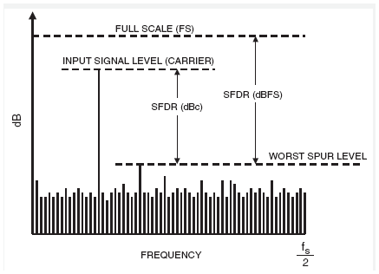
Figure 5.1.1: Illustration of SFDR
For a signal near full scale, the peak spectral spur is generally determined by one of the first few harmonics of the fundamental, however, as the signal falls several dB below full scale, other spurs generally occur that are not direct harmonics of the input signal. This is because of the difference in nonlinearity of the ADC transfer function. The SFDR figure considers all sources of distortion, regardless of their origin.
The sperious free dynamic range is generally much larger than the ADC’s theoreitical N-bit SNR. This is because there is a fundamenta distinction between noise and distortion measurements. Adding extra resolution to an ADC may serve to increase its SNR but may or may not increase its SFDR.

Signal to Noise Ratio
The signal-to-noise ratio of an ADC is the measure of how effectively a signal can be discerned from noise. It is the ratio of the signal power to the non-signal power. Non-signal power includes thermal noise, quantization noise, and other residual errors in the analog to digital converter within the Nyquist band. SNR is typically defined for a continuous sine wave signal applied to the ADC input at some level below the full-scale (FS) level of the converter, usually 0.5dB to 1dB. A visual representation in the time domain and frequency domain can be seen in Figure 5.1.2. The SNR for an ideal converter, where n is the data converter's number of bits, can be calculated.
$$SNR_{Ideal}=\left(1.763+6.03*n\right)dB$$
Unfortunately, numerous factors degrade the ADC's ideal performance resulting in a lower SNR value and higher effective noise figure value. These factors include those mentioned previously along with clock jitter which will be discussed later. Only after fully realizing the amount of noise in the system can calculate a realistic SNR value for the analog to digital converter. This derivation is detailed in the section describing jitter.
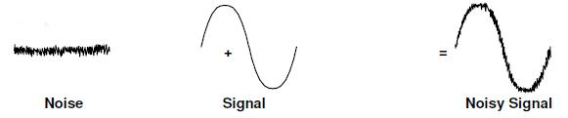
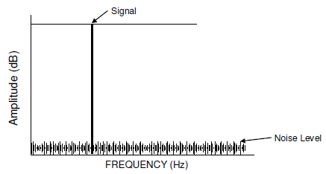
Figure 5.1.2: Illustration of SNR
The SNR of the ADC can be preserved and even improved by limiting the amount of noise into the system, limiting the amount of noise generated by system, and sampling the frequency band of interest at a rate that is greater than the Nyquist rate and then digitally filtering.

Jitter
The importance of a quality clock signal to the ADC is often underestimated. Maximizing noise performance requires a stable clock signal that’s free of phase noise, also know as jitter. Clock jitter is a time variation in the lock time period. When the position of the clock varies slightly, it alters the position of the sampling point, which in turn, samples the input waveform at an imprecise location. The SNR of an ADC is greatly influenced by this figure and special attention must be given to component selection and PBC layout. Jitter can result from the use of a poor clock source, poor component layout, improper grounding, and from energy being coupled into the clock line from other nearby signal sources. When the signal of interest is analyzed by a FFT, because of jitter, the resulting plot will consists of a spread of frequency spikes closely surrounding the fundamental. This will degrade the ADC’s SNR and mask the reception of lower-amplitude signals. As the sample clock jitters left and right, it will acquire the input at different amplitudes as seen in Figure 5.1.3.
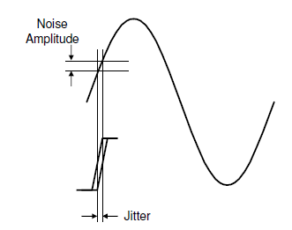
Figure 5.1.3: Noise induced from jitter
The reduction in the ADC’s SNR as a result of the jitter can be calculated; where σ_{T} is the total jitter, σ_{Clk} is the period jitter of the clock driving the ADC encode pins, σ_{aperture} is the jitter internal to the sample and hold circuitry of the ADC, V_{FSR} is the ADC full scale analog input, F_{IN} is the ADC input frequency in Hz, V_{IN} is the ADC input level in dB relative to full scale, and SNR_{ADC} is the published value for the ADC.
$$σ_{T}=\sqrt{σ_{Clk}^{2}+σ_{aperture}^{2}}$$
$$SNR_{jitter}=20*log⁡(\frac{\frac{V_{FSR}}{2}\left(2πF_{IN}\right){10}^{\frac{V_{IN}}{20}}*σ_{T}}{\sqrt{2}})$$
$SNR_{Total}=20*log\sqrt{{10}^{\left(\frac{SNR_{ADC}}{10}\right)}-{10}^{(\frac{SNR_{jitter}}{10})}}$

The AD9460 has an internal jitter value of 60 fs, which alone has little effect the 78.1 dB SNR figure of the ADC. When taking into consideration the added jitter from a noisy external 100 Mhz clock, the resulting SNR is reduced below 64dB. In order to maintain an acceptable SNR figure which is not drastically reduced by external clock jitter, low jitter clock distribution integrated circuits can be used. One such IC is the AD8352, which is capable of producing a differential clock signal with less than 0.50 ps of phase clock jitter.

Total Harmonic Distortion
Total harmonic distortion measures the distortion content of a signal, and is specified in decibels relative to the carrier (dBc). For ADCs, THD is the ratio of the RMS sum of the selected harmonics of the input signal to the fundamental itself. Only harmonics within the Nyquist limit are included in the measurement.
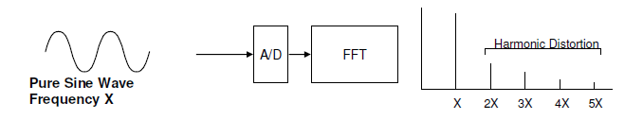
Figure 5.1.4: Introduced harmonic distortion
Non-linearities in a converter’s transfer function will produce harmonics that were not present in the original signal. As a practical matter, there is no such thing as a completely linear input to output transfer function. This non-linearity leads to output distortion. As the input signal swing increases in amplitude, the output becomes more and more distorted. The result is an increase in distortion as the input amplitude increases. THD performance degrades with increasing frequency because the effects of jitter get worse and because the input circuitry becomes slew limited. The THD distortion can be calculated from the following equation, where V₁ is the RMS amplitude of the fundamental frequency and V₂ through V_{N} are the amplitudes of the second through nth harmonics.
$$THD= -20Log\left(\frac{\sqrt{V_{2}^{2}+V_{3}^{2}+V_{4}^{2}…V_{N}^{2}}}{V_{1}}\right)$$

Signal to Noise Ration plus Distortion
Signal to noise plus distortion is a combination of the SNR and the THD specification. It is defined as the ratio, expressed in dB, of the RMS value of the fundamental signal at the output to the RMS value of all of the other spectral components below half the clock frequency, including harmonics but excluding DC. Because it compares all undesired frequency components with the input frequency, it is an overall measure of ADC dynamic performance. The value for SINAD can be calculated using the following equation where SNR_{Total} is the calculated SNR for the ADC and THD is the total harmonic distortion.
$$SINAD= -20*Log\left(\sqrt{{10}^{-\frac{SNR_{Total}}{10}}+{10}^{\frac{THD}{10}}} \right)$$

Effective Number of Bits
The effective number of bits value for a converter is a much more useful specification than is the actual numbers of bits. It is a specification that helps to quantify the realistic dynamic performance of the ADC. This value says that the converter performs as if it were a perfect converter with a resolution of ENOB. The ideal ADC has absolutely no distortion and the only noise it exhibits is quantization noise. The ENOB for an ADC can be calculated from the following equation, where SINAD is the calculated signal to noise plus distortion ratio in dB.
$$ENOB=\frac{SINAD-1.76}{6.02}$$
The ENOB degrades as frequency increases and as the input level decreases for the same reasons that THD and SNR degrade when frequency increases.

Full power bandwidth
Much like any amplifier, analog to digital converters have a frequency range in which normal operation is expected. The effective frequency range of an ADC is not strictly limited by the Nyquist rate. The process of under-sampling is commonly used in RF communications as a way to reduce the sampling speed requirements that would normally need to be satisfied by the Nyquist Theorem. The ADC has an upper frequency limit at which it can still be effective before the output begins to attenuate relative to input. This frequency range is commonly referred to as the full power bandwidth of the ADC and defined as the frequency at which the output is -3dB relative to input signal.

Common Mode Rejection Ratio
Common-mode signals are identical signal components on both the + and - inputs of a differential amplifier or instrumentation amplifier. Common-mode rejection is the ability of a device to reject a signal that is common to both inputs. The common-mode signal can be an AC or DC signal, or a combination of the two. In an ideal differential amp, the common-mode element is cancelled out, since the differential (+ and -) inputs should subtract out the identical components. A measurement of the actual ability to do this is called the Common Mode Rejection Ratio, or CMRR which is often expressed in dB.
Common-mode rejection ratio (CMRR) is often specified for fully-differential inputs and describes the ADCs ability to reject a common-mode (typically DC) voltage. The largest source of common-mode noise is often 50/60Hz noise from power lines, power supply ripple, EMF, RF or high-frequency switching noise.
It is important to note that CMRR is a frequency-dependent parameter. As the frequency of the common-mode voltage increases, the phase matching between AIN(+) and AIN(-) for optimal common-mode rejection becomes more difficult to sustain. As a result, common-mode rejection is less effective at high frequencies.

Intermodulation Distortion
If the ADC input signal consists of more than one spectral component, the ADC transfer function nonlinearity can produce intermodulation distortion (IMD) in addition to THD. Non-linearity in the converter’s transfer function will not only cause distortion of a pure tone; it will also cause two or more signal frequencies to interact with each other. Intermodulation distortion is measured with two or more input signals at different, closely spaced frequencies, all of the same amplitude.
Two Tone IMD is the most common IMD specification and is measured with two input frequencies. Ideally, input frequencies f1 and f2 should produce output frequencies of only f1 and f2. Device non-linearities, however, cause the production of new frequencies at the sum and difference frequencies of the input signals and their harmonics. i.e. (f1 + f2), (f2 - f1), (f1 + 2f2), (2f1 + f2), (2f1 - f2), (2f2 - f1), etc. The amplitudes of the various intermodulation products will depend upon the nature of the non-linearities involved. IMD can be expressed as the ratio of the power in the intermodulation products to the power in one of the original input frequencies. Some applications, particularly those concerned with RF signal processing, are more sensitive to some modulation products than to others. For example, in RF applications the third-order difference products (2f1 - f2 and 2f2 - f1) are important because they are closest to the input frequencies, where other terms that are farther from the input frequencies can be digitally filtered out. For this reason the terms other than 3rd order terms are often ignored where IMD is specified for RF applications.

Quantization Error/ Transition Noise
Quantization error is the range of input voltages that cause an ADC output to toggle between adjacent output codes. As the analog input voltage increases, the voltages that define where each code transition occurs are uncertain due to the associated transition noise.
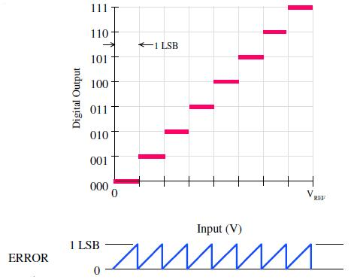
Figure 5.1.6: Quantization error
This error results from the finite resolution of the ADC. The ADC can only resolve the input into 2^{n} discrete values. Each output code represents a range of input values.
The converter resolution, then, is 2^{n}. So, for a 2.0 Volt reference, a 16-bit converter resolves the input into VREF/2¹⁶ = 2.0V/65536 = 30.51 µV steps. Quantization error, then, is a round off error.

Differential Non-Linearity error
DNL is used to describe the error in step size. DNL is the difference between the ideal and the actual input code width. The input code width is the range of input values that produces the same digital output code. For positive DNL we look at the widest input code range. For negative DNL we look at the narrowest code range.
In an ideal converter, the code-to-code transition points are exactly 1 LSB apart. The difference between the ideal 1 LSB and the worst case actual input voltage change between output code transitions is called Differential Non-Linearity.
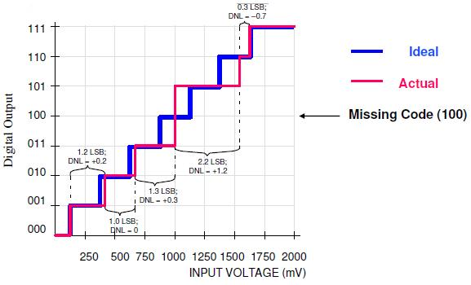
Figure 5.1.7: Differential nonlinearity error
To avoid missing codes in the transfer function, DNL should be greater (more positive) than -1.0 LSB. DNL indicates the deviation from the ideal 1 LSB step size of the analog input signal corresponding to a code-to-code increment. DNL, a static specification, relates to SNR, a dynamic specification. However, noise performance can not be predicted from DNL performance, except to say that SNR tends to become worse as DNL departs from zero. When no value of input voltage will produce a given output code, such that the code in question never appears in the output, that code is missing from the transfer function and is known as a missing code.

Integral Non-Linearity error
Integral Non-linearity describes the departure from an ideal linear transfer curve for an ADC. INL does not include quantization errors, offset error, or gain error. It is a measure of the straightness of the transfer function and can be greater than the differential non-linearity. The size and distribution of the DNL errors will determine the integral linearity of the converter. INL is a static specification and relates to THD (a dynamic specification). However, distortion performance can not be predicted from the INL specification, except to say that THD tends to become worse as INL departs from zero.
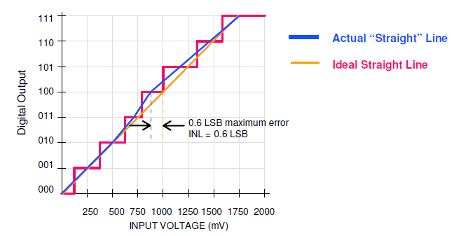
Figure 5.1.8: Integral nonlinearity

SECTION 5.2 – ANALOG/DIGITAL ACCURACY

Resolution and accuracy are terms that are often interchanged when the performance of an ADC is discussed. It is important to note that resolution does not imply accuracy nor does accuracy imply resolution.
The accuracy of the analog to digital converter determines how close the actual digital output is to the theoretically expected digital output for a given analog input. In other words, the accuracy of the converter determines how many bits in the digital output code represent useful information about the input signal.
The loss in the ENOB or accuracy becomes worse if the difference between the ADC Reference and maximum signal level to the ADC increases. It is important to match the ADC dynamic range to the maximum signal amplitude for best accuracy.

SECTION 5.3 – ADC Hardware

The AD9460 is a 16-bit, 105MSPS ADC, with an adjustable analog input voltage swing from 2.0Vp-p to 4.0Vp-p, p, selectable CMOS or LVDS outputs, 78.1dB SNR at 10Mhz, 77.4dB SINAD at 10Mhz, 88dBc SFDR at 10Mhz, and 60 fs of internal clock jitter. This ADC has excellent linearity (±0.5 DNL, ±3 INL), and excellent noise and distortion performance stats (90 dBFS two-tone test). This analog to digital converter requires three separate sources: an analog 3.3V source, analog 5V source, and a 3.3V digital source.
It is strongly recommended that the analog inputs of the AD9460 be driven differentially to achieve the best noise performance. The benefit of using differential pairs is that any common mode noise that is introduced in the traces will be removed from the signal when the difference is computed in the ADC. To achieve this from a single ended source, we plan to utilize the AD8352 which is an ultralow distortion, low noise RF amplifier capable of converting a singled ended source to a differential ended signal. This amplifier is also able to apply an additional 20dB of gain to the input signal which can be used to fully utilize the 2.0Vp-p analog input swing.
The SNR of the ADC is greatly influenced by the amount of clock jitter that is present. The ADC has an internal jitter of 60fs which results in an SNR of 78.1dB at 10MHz. This figure, however, does not take into account other sources of jitter that will be introduced to the system. The AD9573 is PLL core clock generator which will output a 100MHz square wave with a published phase jitter of 0.54ps. With the addition of 0.54ps to the ADC, the value of SNR changes very little to 77.73dB at 10MHz.
The effective performance of the ADC is only as good as its resolution after all non-ideal factors have been taken into consideration. The SINAD is the measure of the signal to noise plus distortion ratio. This value takes into consideration the SNR and the THD of the system. From this value, the effective number of bits can be calculated, which treat the ADC as if it were a theoretical perfect converter with a resolution of ENOB. With an SNR of 77.73 dB, the effective number of bits for the ADC is calculated to be 12.37. Treating this as an ideal ADC, we can then recalculate the resolution which is 377.82 μV. The 50dB of gain from the LNA and gain stages followed by the 20dB of gain from the ADC driver, amplify the 1µV value to 31.62 mV, well within the ADC’s resolution.

SECTION 6.0 – Digital Hardware

Section 6.1 – FPGA
Although most of the frequency analysis will be done by the PC, hardware is required to process the digitized high frequency signals into data that can be sent over USB to the PC. This can be accomplished using a field programmable gate array (FPGA). The digital signal processing that will be implemented on the FPGA is summarized in the block diagram shown below.

Figure 6.1.1 – FPGA Block Diagram

Section 6.1.1 – ADC Interface

The first step of the process is the conversion for the ADC. The ADC will output a datastream in the form shown in Figure 6.1.1.2.
Figure 6.1.1.2 – Timing Diagram for ADC Data Output
Each of the data bits will be encoded according to the format shown in Table 6.1.1.1.
Table 6.1.1.1 – Data Output Formatting
The digital two’s complement mode will be the mode chosen to output the data from the ADC. Also, the 2V_{pp} input span will not be used. Rather, the 2.25 input voltage range will be used with a common mode voltage of 1.25 V. Thus, the input voltage will be in the range of 0.1250 V to 2.3750V. ADC interface will take the raw digitally encoded table and convert it back into signed representations of the input voltage. The ADC output codes are represented as 16 bit integers. However, the interface will generate signed 20 bit numbers, where 17 bits are fractional. The whole point of the ADC is high precision conversion. This precision requires at least 5 significant digits after the decimal of representation. Thus, the number of bits required to represent such a decimal is given in Equation 6.1.1.1.
$$N_{frac}=\frac{\log_{10}\left({10}^{4}\right)}{\log_{10}\left(2\right)}=17 bits (6.1.1.1)$$
The rest of the bits are for the non-fractional part of the number. Since the highest value is 2.3750 V, two bits are needed to represent the non-fractional part of the number. Finally, a signed bit is required, for a total of 20 bits.

Section 6.1.2 - Mixing and Sinusoid Generation

Next, a mixer is required to separate the incoming signal into in-phase and quadrature components, as well as to down-shift the frequency of the incoming signal. The idealized mixer operates by multiplying an input signal with an intermediate signal. In this case, the intermediate signal will be supplied by a local oscillator, so it will be a sinusoid. This is illustrated in Figure 6.1.2.3.
Figure 6.1.2.3: Mixer with Local Oscillator
The output of the mixer in the time domain is shown in the equations below.
$$y\left(t\right)=x\left(t\right)\cos\left(ω_{0}t\right) (6.1.2.1)$$
$$y\left(t\right)=x\left(t\right)\frac{e^{jω_{0}t}+e^{-jω_{0}t}}{2} (6.1.2.2)$$
Now, the frequency spectrum of such a signal can be considered. If the frequency shifting property of the Fourier transform is applied (as well as the more general properties of linearity of Fourier transforms):
$$Y\left(ω\right)=\frac{X\left(ω-ω_{0}\right)}{2}+\frac{X\left(ω+ω_{0}\right)}{2} (6.1.2.3)$$
From the above equation, it is clear that mixer will produce two copies of the input bandwidth: one centered at f_{in} - f_{IF}, and another centered at f_{in} + f_{IF}. The bandwidth of the input signal is 4MHz.Therefore, the mixer will have an intermediate frequency of 18 MHz.Thus, the first image will have a frequency range between DC and 4MHz. The second image will be centered at 38 MHz, and exist in the range 36Mhz and 40 Mhz.
The intermediate frequency signal for the mixer(s) will need to be digitally generated as well. This can be accomplished in one of two ways. The first method involves using a lookup table based numerically controlled oscillator (NCO). The lookup table grants a high degree of accuracy, with a cost in terms of area. Such an NCO would take up the majority of the 18x18 MUX modules and the look-up-table modules in the FPGA, and further development would be problematic.
The second method involves using a CORDIC to generate the sine and cosine waves by incrementing a phase input. This is essentially accomplished though the rotation of unit vectors along the unit circle (since the points on the unit circle can be used to represent a complex number in rectangular form x + iy, which inherently has magnitude and phase just as a vector does). CORDIC is an iterative algorithm where feedback can be used to get closer and closer to the correct computation of the sine and cosine of an angle with each subsequent iteration.
The CORDIC would be able to output a digitally controlled sine and cosine wave in the exact same format as the input data from the ADC (signed, fractional two’s complement). Thus, the two signals would be able to be mixed one sample at a time through the use of binary multipliers.

Section 6.1.3 – Low Pass Filtering

Next, low-pass filters would be used to attenuate the frequency content on the high end of the spectrum. These filters would be implemented as quantized, symmetric FIR filters. A basic block diagram of an FIR filter is shown below in Figure 6.1.4.
Figure 6.4.1 – FIR Filter Structure
Clearly, the above system can be implemented using flip-flops as delay elements and multiply-and-accumulate functions for the sums of the products of the gain blocks and the sample-delayed versions of the inputs and outputs.

Section 6.1.4 – CIC Filtering

Finally, cascaded-integrator comb filters can be used to decimate the signals so that they can be sent efficiently over USB. The CIC filters can sometimes be more area-efficient than their FIR counterparts, because they do not require multiplication elements: only delays and summations (flip-flops and adders). The CIC filter is implemented as a series of comb filter blocks, followed by a series of integrators, as shown in Figure 6.1.4.1.
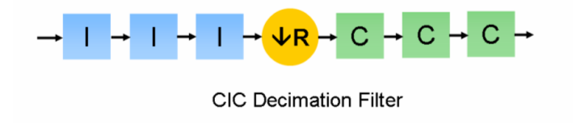
Figure 6.1.4.1 – CIC Filter Block Diagram
Once the data has been downconverted into a manageable sampling rate, the parallel bit representations can be converted to serial, and transmitted over USB. Now, the decimation factor of the CIC filter must be computed. The maximum data transfer rate for the USB will be set at 128 Mbps. Therefore, the decimation factor must be calculated to meet this. The incoming data transfer rate is given by Equation 6.1.4.1.
$$B_{TX}=N×F_{s}=\left(16 bits\right)×\left(80 MHz\right)=1280 Mbps (6.1.4.1)$$
Now, there are actually two data streams for the in-phase and quadrature components. So, the actual transfer rate is 2560 Mbps. Now, the decimation factor is given by Equation 6.1.4.2.
$$R=\frac{{2B}_{TX}}{B_{ideal}}=\frac{2\left(1280 Mbps\right)}{128 Mbps}=20 (6.1.4.2)$$
So, the incoming sampling rate of 80 Msps will be decimated by a factor of 20 leaving a sampling rate of 4 Msps.
In Figure 6.1.6, the “I” blocks are integrators, and the “C” blocks are comb filters. The z-transform of the integrator block is given by Equation 6.1.4.3.
$$H_{I}\left(z\right)=\frac{1}{1-z^{-1}} (6.1.4.3)$$
The z-transform of the comb filter blocks is given by Equation 6.1.4.4.
$$H_{C}\left(z\right)=1-z^{-M} (6.1.4.4)$$
In this case, M represents the differential delay of the filter. Generally, this factor is limited to 1 or 2. In the case of this design, it will be 1. Thus, the total response of the filter is calculated through multiplication (as the blocks are cascaded), knowing that there are N blocks.
$$H\left(z\right)={\left[H_{I}\left(z\right)\right]}^{N}{\left[H_{C}\left(z\right)\right]}^{N}={\left[\sum_{k=0}^{RM-1}{{\left(\frac{1}{z}\right)}^{k}}\right]}^{N} (6.1.4.5)$$
This product of geometric series can be evaluated as Equation 6.1.4.6.
$$H\left(z\right)={\left(\frac{1-\frac{1}{z^{RM}}}{1-\frac{1}{z}}\right)}^{N} (6.1.4.6)$$
Now, the frequency domain response of the above system can be computed by making the substitution $z=e^{j2πf}$.
$$H\left(z\right)={\left(\frac{1-e^{-j2πfRM}}{1-e^{-j2πf}}\right)}^{N} (6.1.4.7)$$
This can be simplified using complex algebra. The details will not be discussed. The result is shown as Equation 6.1.4.8.
$$\left|H\left(f\right)\right|={\left|\frac{\sin\left(πMf\right)}{\sin\left(\frac{πf}{R}\right)}\right|}^{N} (6.1.4.8)$$
Substituting in the given parameters for our CIC filter, Equation 6.1.4.9 results. In this case, N (the number of stages) was chosen to be 3. A large number of stages is not desirable because it will increase the gate-implementation cost that will be required of the FPGA.
$$\left|H\left(f\right)\right|={\left|\frac{\sin\left(πf\right)}{\sin\left(\frac{πf}{20}\right)}\right|}^{3} (6.1.4.9)$$

Altera provides Matlab code for CIC filter design. This code was used to determine the frequency response of the CIC filter for the receiver (assuming fixed point construction). This frequency plot is shown in Figure 6.4.1.2.
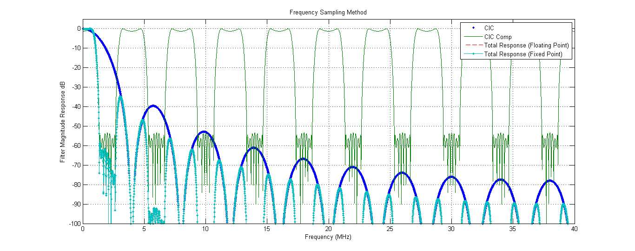
Figure 6.4.1.2 – CIC Filter Frequency Response
Another matter to consider is the bit-width of the CIC filter. Because there is a possibility of overflow in the integrator stages at DC frequencies or at frequencies equal to the sampling rate, it is necessary to increase the data register using Equation 6.1.4.10.
$$B_{out}=ceil\left(N\log_{2}\left(RM\right)+B_{in}\right) (6.1.4.10)$$
When the actual data is output, it is necessary to translate the padded output word back into the intended word length.

Section 6.1.5 – System Simulation

The entire system was implemented in Simulink, in order to take advantage of the Simulink-to-HDL coder later in the design. The system is shown in Figure 6.1.5.1.
Figure 6.1.5.1 – Simulink Model of FPGA System
The system was tested with a 16-bit digital signal representing a 1 mV sine wave at 20.1 MHz. If the system works correctly, the output should be a down-mixed version of the sine wave at 1 MHz at a new sampling rate of 4 Msps. The output FFT plots for the in-phase and quadrature components are shown in Figures 6.1.5.2 and 6.1.5.3 respectively.
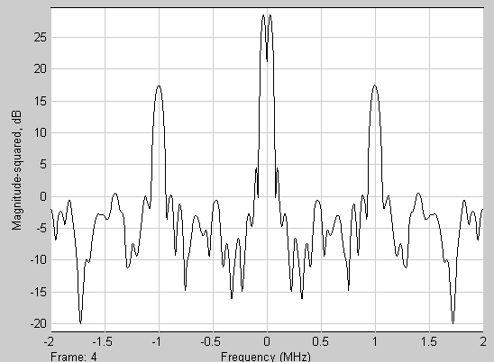
Figure 6.1.5.2 – In-Phase Frequency Response
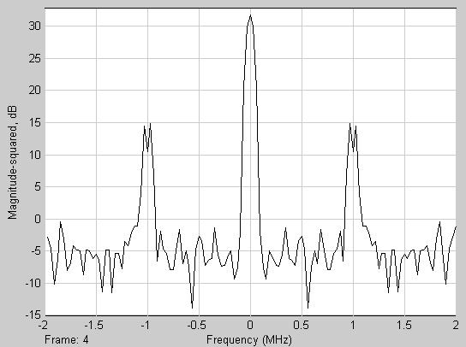
Figure 6.1.5.3 – Quadrature Frequency Response
The window of the FFT sink is preset to span the range [-Fs/2, Fs/2]. Therefore, the limits of the plot dictate that the sampling frequency is 4 MHz, exactly as designed. Furthermore, the spectrum in the plot is clearly the Fourier transform of a sinusoid with an added DC component. Both impulses are centered at -1 and +1 Mhz in both graphs. Therefore, the spectrum represents a 1 MHz sinusoid. Therefore, the system works as intended.

Section 6.2 – USB
The USB microcontroller is an important part of this project. It is used to take the parallel data lines from the FPGA and serially transfer the digitized spectrum data to the PC for additional signal processing.
The USB 2.0 specification supports 3 speeds of operation: low-speed (1.5Mbps), full-speed (12Mbps), and high-speed (480Mbps). Both low-speed and full-speed signaling rates are to slow to meet minimum speed of the data. A high-speed USB microcontroller is required to continually stream the data from the receiver to the PC.
The analog to digital converter has a dynamic range of 16 bits. In order to accurately sample the 20.1MHz spectrum, the ADC is running at 100MHz. Therefore, the data stream out of the ADC is 1600Mbps. This is far too much data to send over the USB bus at a single time, so the signal is filtered and decimated inside the digital down converter. A decimation rate of 20 will drop the signal to 80Mbps, however, since there is both I and Q components to the data stream, 160Mbps will need to be sent over the bus. This is sufficiently far away from the 480Mbps theoretical maximum that it won’t overload the USB bus.
The USB 2.0 specification specifies 4 modes of operations: control, bulk, interrupt, and isochronous. The isochronous mode is typically used for streaming data, such as sound or video data. Isochronous mode guarantees that data will be sent at a constant bandwidth; however, it does not provide any error detection or correction. Because of its use for real-time signals, the isochronous mode of the USB protocol will be used to transfer the data. Per the USB 2.0 specification and EZ-USB Technical Reference Manual, isochronous mode can transfer 3 1024 byte packets per USB frame. A hi-speed USB frame is issued every 125μS. Therefore, the maximum data rate for isochronous mode is approximately 24 MBps (192 Mbps).
The USB transceiver chip used in this design is the EZ-USB FX2LP (CY7C68013A) from Cypress Semiconductor. This chip contains 4 programmable USB endpoints, capable of transferring data in isochronous mode. The chip also meets the USB 2.0 specification, which allows it to transfer in high-speed mode (480Mbps). Also on the chip is an enhanced 8051 microcontroller. According to the EZ-USB Technical Reference Manual, the CPU simply configures the interface, then ‘gets out of the way’ while the unified EZUSB FIFOs move the data directly between the USB and the external interface. Figure 6.2.1 shows the architecture of the FX2LP EZ-USB chip.
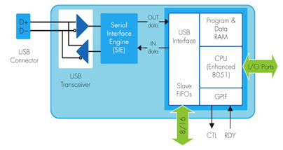
Figure 6.2.1: Architecture of the FX2LP

Section 6.3 – Programming and Configuration

When the FX2LP is attached to the USB bus, it will enumerate with a VID of 0xB404 and PID of 0x0410. Since the FX2LP does not contain any non-volatile storage, and therefore cannot store its firmware. Therefore, an I2C EEPROM chip will be used to store the firmware for the FX2LP. This firmware will be loaded automatically on power-up set up the chip in the correct isochronous, high-speed configuration, and will do a soft reset to enumerate with the new firmware. Once the device has enumerated with the correct firmware, libUSB1 will be used to communicate with the operating system to get the data off the USB bus. Section 7.4 describes the device drivers in more detail.

SECTION 7.0 – SOFTWARE

Section 7.1 – Introduction
A key component in any software defined radio receiver is a host PC running signal processing software. Therefore, a major component of the receiver architecture will be custom software written to decode and process the signal from the receiver via the USB port. The software can be broken up into several components. These are:
- USB Drivers (see Section 7.4)
- Graphical User Interface (GUI)
- Signal Processing Blocks
- Logic “Glue”
The GUI and logic glue will be written in Python 2.7. The GUI will use the wxWidgets framework with Python bindings provided by wxPython. The core of the signal processing blocks will be provided by the GNU Radio software suite. This component is discussed Section 7.5.

Section 7.2 – Software Modes of Operation

To aid amateur radio astronomers, the software will have four basic modes of operations. Those modes are as follows:
- Real Time
- Radio Astronomy
- Full Record
- Data Analysis
In “Real Time” mode, live or previously recorded data is processed into an audio signal and played in real time. The user should be able to select what portion of the total 1MHz bandwidth should be mixed to audio. This means the user should be able to adjust the center frequency and bandwidth of the audio signal, as well as the resulting audio bitrate. Also, the processed audio streams can optionally be recorded and saved to the hard drive or other storage media. While in “Real Time” mode, the software should also plot frequency vs. time vs. signal strength. Time will be plotted on the x-axis, frequency will be plotted on the y-axis, and signal strength will be shown in color on the resulting plot. The user should be able to save the plots as a picture (i.e., JPEG, bitmap, etc.).
The “Radio Astronomy” mode gives the user the ability to plot a live or previously recorded data by taking the integrated RMS average of signal energy over the entire 1MHz bandwidth and plotting this average over time. A constant 10ms filter window should be used to average over. The user should also be able to export the averaged data in a parsable format (i.e., CSV).
The “Full Record” mode will save all unprocessed, digitized I and Q streams to a WAV format. Channel 0 of the WAV file will contain the I stream, channel 1 will contain the Q stream. The user should be able to configure how much data the program should store. The user should be able to select whether a buffer should be used to only store a certain amount of data, or whether the program should continue to record until out of disk space. Also while in “Full Record” mode, a plot should be displayed showing time on the x-axis, frequency on the y-axis, and signal strength in color.
The “Data Analysis” mode will give the user the ability to analyze previous recorded I/Q data recorded in “Full Record” mode in “Radio Astronomy” mode.

Section 7.3 – Operating System and Runtime Environment
The software was required to operate under Ubuntu Linux, version 10.10. A Debian software package is required to make installation of the software easy to the end user. Use of a package will also make installation of dependency software (i.e., GNU Radio, Python 2.x, etc.) easy for the end user.

Section 7.4 – LibUSB and USB Software

The firmware for the FX2 will put the FX2 into isochronous mode. This mode guarantees a specific bandwidth will be transferred over the USB at one time and is ideal for data-streaming applications.

Section 7.5 – GNU Radio
The GNU Radio software suite is an open source software suite designed for use with software defined radios. GNU Radio provides signal processing blocks used to analyze incoming data from the receiver. GNU Radio is written in both C++ and Python. Due to the speed requirements of software defined receivers, the signal processing blocks of GNU Radio are written in C++. Due to the compiled nature of C++, versus the interpreted nature of Python, C++ code is significantly faster than Python. However, most of these compiled C++ signal processing blocks can be accessed via Python bindings. This allows these fast, low-level signal processing blocks to be incorporated into a high-level, rapid development project using Python.
The signal processing blocks implemented in GNU Radio were prototyped in the GNU Radio Companion (GRC). The GRC is a graphical application which can be used to generate signal processing applications using the blocks provided by GNU Radio. The signal processing application will be responsible for deinterleaving both the I and Q components from the data stream. It will provide graphical outputs (i.e. waterfall plots), file outputs (i.e. WAV file output), and real time audio output, based on the mode selected by the user. Figure 7.5.1 and 7.5.2 show the flow diagrams for the “Full Record” and “Real Time” modes.
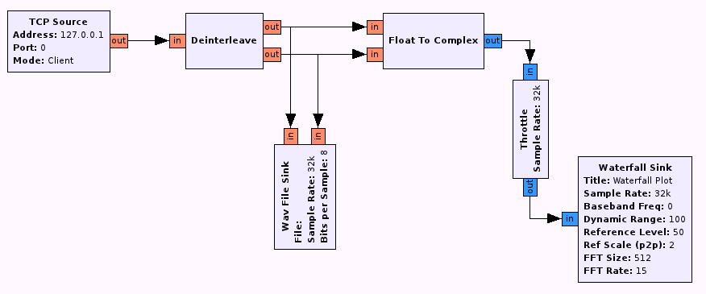
Figure 7.5.1: Flow Graph Showing “Full Record” Mode Using GNU Radio Blocks
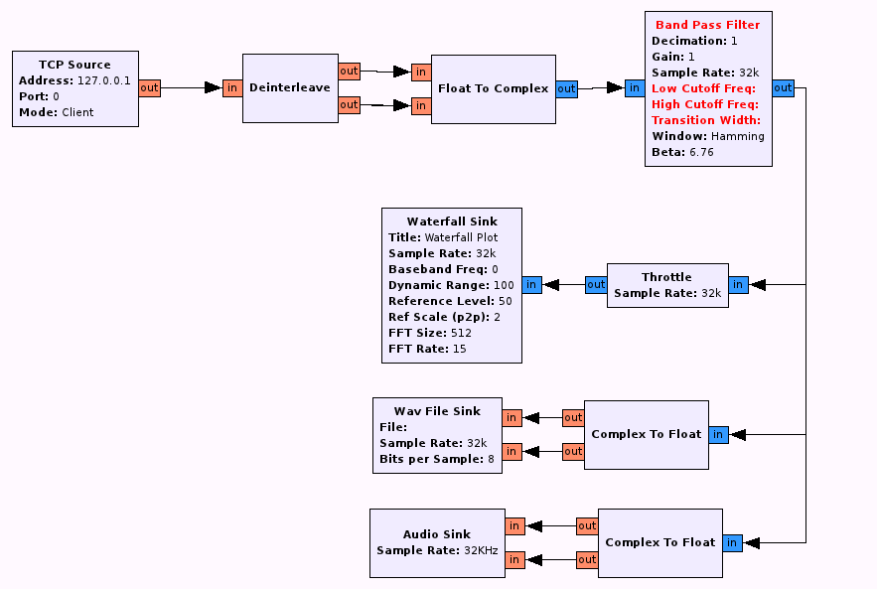
Figure 7.5.2: Flow Graph Showing “Real Time” Mode Using GNU Radio Blocks

Section 7.6 – Python
Python is an interpreted, high-level scripting language. Due to its high-level of abstraction, it is useful in rapid development applications. Python requires that the Python interpreter be installed on the machine. Under Ubuntu, this is made easy using the built-in package manager.
Python is currently being developed with two main versions, 2.x and 3.x. Due to differences in each version, neither is compatible with the other. Python 3.x is considered more recently and in the future, development of the 2.x branch will be dropped. However, currently, most applications, packages, and modules use the 2.x branch, including the GNU Radio platform. Because of this, the custom receiver software will be written using Python 2.x. Migration to the 3.x branch in the future can be aided by tools such as Python’s 2to3 utility, which will convert existing code written in Python 2.x to code compatible with Python 3.x.

Section 7.7 – wxPython
The wxPython framework provides bindings and wrappers to the wxWidgets framework written in C++. wxWidgets is an open-source framework which can create a graphical user interface for Linux, Windows, OS X, and UNIX. wxWidgets uses the platform’s native API to construct the GUI, which gives it a native look and feel. Bindings are available for Python using the wxPython module.
A utility called wxGlade is available to graphically construct wxWidgets applications. This utility allows for drag and drop GUI component placement and rapid GUI construction. wxGlade can be used to generate source code of the GUI in Python, C++, Perl, Lisp, and XRC. wxGlade will be used to generate Python code for use in the GUI.

Section 7.8 – Software Licensing
Due to the open-source nature of this project, and the open-source projects used in implementing this project, all source code will be licensed under the GPLv3. This license stipulates that all source code be made available, and any derivative works of this project also be licensed under the GPL. Also, all hardware schematics, gerber files, and documentation will be released with the source code.

Appendix A

Schematics

Appendix B

Budget

Appendix C

Matlab Verification and Testbench Waveforms

Figure C.1 – Matlab Code to Read Values from FPGA Output

clc;
clf;
close all;

%directory (virtualbox windows xp)
cd('C:\Documents and Settings\Dan\My Documents\Dropbox\Senior Project - SDR\Simulation\MATLAB');

%% GET DATA

%get text file holding data
[file_name_1, mach_path_1] = uigetfile({'*.*', 'All Files(*.*)';'*.txt*', 'Text File'; '*.dat*', 'Data File'},'Select Text File for Data');

if isequal([file_name_1,mach_path_1],[0,0]) % If "Cancel" is selected then return
disp('Action cancelled');
return
else % Otherwise construct the fullfilename and Check and load the file
file_1 = fullfile(mach_path_1,file_name_1);
end
b=[]; %initializes a null matrix

fid = fopen(file_1, 'r');
%A = fscanf(file_data, '%d\t%d\t%d\t%d\t%d\t%d\t%d', [7 7]);
%A=fread(file_data,'*char');
%A=textscan(file_data,'%d %d %d %d %d %d %d');
while 1
tline=fgetl(fid);
if ~ischar(tline),break, end
a=str2num(tline);
b=[b;a];
end;
fclose(fid);

inc=b(:,1);
off=b(:,2);
sin_0=b(:,3);
cos_0=b(:,4);
%q_err=b(:,5);
in_p=b(:,5);
qu_p=b(:,6);

for count=1:1:numel(cos_0)
temp=dec2bin(cos_0(count),20);
sum=0;
for index=1:1:length(temp)
if(index==1)
sum=-(2^(length(temp)-1))*temp(index)+sum;
else
sum=(2^(length(temp)-index))*temp(index)+sum;
end
end
cos_0(count)=sum;
end

for count=1:1:numel(sin_0)
temp=dec2bin(sin_0(count),20);
sum=0;
for index=1:1:length(temp)
if(index==1)
sum=-(2^(length(temp)-1))*temp(index)+sum;
else
sum=(2^(length(temp)-index))*temp(index)+sum;
end
end
sin_0(count)=sum;
end

plot([sin_0 cos_0])
legend('digital sine', 'digital cosine');
title('NCO output, signed 20 bit, 17 bit fraction, 3 bit whole')
xlabel('samples, 50 MHz sampling')
ylabel('20 bit signed y[n]')

for count=1:1:numel(in_p)
temp=dec2bin(in_p(count),20);
sum=0;
for index=1:1:length(temp)
if(index==1)
sum=-(2^(length(temp)-1))*temp(index)+sum;
else
sum=(2^(length(temp)-index))*temp(index)+sum;
end
end
in_p(count)=sum;
end

for count=1:1:numel(qu_p)
temp=dec2bin(qu_p(count),20);
sum=0;
for index=1:1:length(temp)
if(index==1)
sum=-(2^(length(temp)-1))*temp(index)+sum;
else
sum=(2^(length(temp)-index))*temp(index)+sum;
end
end
qu_p(count)=sum;
end

figure;
plot([in_p qu_p])
legend('y_I[n]', 'y_Q[n]');
title('Mixer + LPF output, signed 20 bit, 17 bit fraction, 3 bit whole')
xlabel('samples, 50 MHz sampling')
ylabel('20 bit signed y[n]')
Figure C.2 –ADC Data Output Simulation

clc;
close all;

f_s = 80*10^6; %define fs = 80 MSPS
f_max = f_s/2; %define maximum random signal frequency we will generate using Nyquist criterion

delta_t = 1/(2*pi*f_s); %sample time
N = 1000; %number of points to sample

t = 0:delta_t:N*delta_t; %time vector

%we will design for a dynamic range of 100 dB. Therefore, out highest
%signal will be 100 dB higher than the minimum exected signal of 1*10^-6;
A_min = 10^(-6);
A_max = db2mag(100)*A_min; %define amplitude of signals

num = input('Define number of sinusoids in simulation ');
num = round(num);

phase_min = 90;

x = zeros(1,length(t));

y = 0;

for count = 1:1:num
if(count == num)
f = 20.1*10^6; % f = 20.1 MHz (signal of interest)
phase = 0; %assume 0 phase shift
A = A_min; %expected signal amplitude is 1 uV
else
f = round(f_max*rand(1,1)); %random frequency between 0 and f_s/2
phase = (round(90*rand(1,1)))*pi/180; %random phase between 0 and 90 deg
A = A_max*rand(1,1); %range amplitude between 0 and A_max
end

display(['amplitude ', num2str(count), ' = ', num2str(A)]);
display(['frequency ', num2str(count), ' = ', num2str(f)]);
display(['phase ', num2str(count), ' = ', num2str(phase*180/pi)]);
display(' ');
x=A*sin((2*pi*t*f)+phase);
y = y + x;
end

figure('Name','Simulation Plots at Antenna Output','NumberTitle','off');

plot(t,y);
xlabel('t (sec)');
ylabel('y (V)')
title('Sum of Sinusoids in Time Domain y(t)')

my_bpf_coeffs = [-0.000819583116761776,0.00158935347782873,0.00145489209498908,-0.00122689224772276,-0.00153558753128254,0.00173134633610089,0.00188506386745106,-0.00188012651897948,-0.00190043442515253,0.00171954430704772,0.00150402535174710,-0.00104700532146194,-0.000510872459469262,-0.000296531119953273,-0.00123217486688743,0.00245534391206391,0.00385260363026379,-0.00553356084007824,-0.00742221429615046,0.00956959377471826,0.0119438758004732,-0.0145297974648472,-0.0173390728882779,0.0202917612469743,0.0234419479415883,-0.0266492387794744,-0.0300044909660255,0.0333176971584589,0.0367081916446284,-0.0399549364890033,-0.0431906974966633,0.0461846951044717,0.0490702379747963,-0.0516283263020765,-0.0539806770498847,0.0559395626045479,0.0576027504084113,-0.0588335749811329,-0.0596948817666310,0.0601148540280162,0.0601148540280162,-0.0596948817666310,-0.0588335749811329,0.0576027504084113,0.0559395626045479,-0.0539806770498847,-0.0516283263020765,0.0490702379747963,0.0461846951044717,-0.0431906974966633,-0.0399549364890033,0.0367081916446284,0.0333176971584589,-0.0300044909660255,-0.0266492387794744,0.0234419479415883,0.0202917612469743,-0.0173390728882779,-0.0145297974648472,0.0119438758004732,0.00956959377471826,-0.00742221429615046,-0.00553356084007824,0.00385260363026379,0.00245534391206391,-0.00123217486688743,-0.000296531119953273,-0.000510872459469262,-0.00104700532146194,0.00150402535174710,0.00171954430704772,-0.00190043442515253,-0.00188012651897948,0.00188506386745106,0.00173134633610089,-0.00153558753128254,-0.00122689224772276,0.00145489209498908,0.00158935347782873,-0.000819583116761776;];

filter_out = conv(my_bpf_coeffs, y);
filter_out = filter_out(1:length(t));

figure('Name','Simulation Plots after Bandpass Filter','NumberTitle','off');

plot(t,filter_out);
xlabel('t (sec)');
ylabel('y (V)')
title('Sum of Sinusoids in Time Domain after Filtering r(t)')

lna_gain = 18;
secondary_gain = 20;
gain = lna_gain + secondary_gain;
gain = 10^(gain/20);

ADC_amp_in = gain*filter_out;

figure('Name','Simulation Plots after Gain','NumberTitle','off');

plot(t,ADC_amp_in);
xlabel('t (sec)');
ylabel('y (V)')
title('Sum of Sinusoids in Time Domain after Gain g(t)')

ADC_amp_in = ADC_amp_in(round(0.1*N):length(ADC_amp_in)); %data CHOP!

figure('Name','CHOPPED DATA','NumberTitle','off');

plot(t(round(0.1*N):length(t)),ADC_amp_in);
xlabel('t (sec)');
ylabel('y (V)')
title('Sum of Sinusoids in Time Domain after Gain g(t)')

ADC_range = 2.25;
ADC_supply = 3.3;
ADC_ref = 1.25;
ADC_max = ADC_ref + ADC_range/2;
ADC_min = ADC_ref - ADC_range/2;

N = 16; %number of ADC bits is 16
mode = 'offset';
volt_res = ADC_range/(2^N); %compute voltage resolution
LUT = zeros(2^N,16+1+20+1);
factor = 100000; %17 bits for decimal, therefore, 2^17 = , closest multiple of 10 is 100,000

volt_min = -(ADC_range/2);
volt_max = ADC_range/2;

%
% LUT [15:0] = bits representing count value (0 - 2^N-1)
% LUT [16] = ADC input voltage code
% LUT [36:17] = 20 bit scaled represenation of input voltage code
% LUT [37] = output interpreted code
%

for count=1:1:(2^N)

if(count<2^(N-1))
bin_count=dec2bin(count-1,15);
bin_count = strcat('0', bin_count);
else
bin_count=dec2bin(count-(2^(N-1)),15);
bin_count = strcat('1', bin_count);
end

for index=1:1:N
LUT(count,index)=str2num(bin_count(index));
end

number = single(ADC_min+(volt_res*count));
LUT(count,16+1)=single(number);

if(number>=0 && number<1)
new_number=(number)*factor;
int_c = 0;
elseif(number>=1 && number<2)
new_number=(number-1)*factor;
int_c=1;
elseif(number>=2 && number<3)
new_number=(number-2)*factor;
int_c=2;
else
new_number=(number-3)*factor;
int_c=3;
end

new_bin=dec2bin(new_number,17);
new_bin_c=dec2bin(int_c,3);
LUT(count,18)=str2num(new_bin(1));
LUT(count,19)=str2num(new_bin(2));
LUT(count,20)=str2num(new_bin(3));

for index=1:1:17;
LUT(count,index+16+1+3)=str2num(new_bin(index));
end

div=number/count;
%disp(num2str(div));
LUT(count,16+2+20)=div;

%disp(['code = ', bin_count, ' for voltage = ', num2str(number), ' [V]', ' is ', new_bin_c, '_', new_bin]);
end

Figure C.3 – Model of Code Translated Signed Multiplication

clc; %clear screen
clf; %clear figure
close all; %close all figures

ADC_range = 2.25;
ADC_supply = 3.3;
ADC_ref = 1.25;
ADC_max = ADC_ref + ADC_range/2;
ADC_min = ADC_ref - ADC_range/2;

N = 16; %number of ADC bits is 16
mode = 'offset';
volt_res = ADC_range/(2^N); %compute voltage resolution
LUT = zeros(2^N,16+1+20+1);
factor = 100000; %17 bits for decimal, therefore, 2^17 = , closest multiple of 10 is 100,000

volt_min = -(ADC_range/2);
volt_max = ADC_range/2;

for count=1:1:(2^N)
bin_count=dec2bin(count-1,16);

for index=1:1:N;
LUT(count,index)=str2num(bin_count(index));
end

number = single(ADC_min+(volt_res*count));
LUT(count,16+1)=single(number);

if(number>=0 && number<1)
new_number=(number)*factor;
int_c = 0;
elseif(number>=1 && number<2)
new_number=(number-1)*factor;
int_c=1;
elseif(number>=2 && number<3)
new_number=(number-2)*factor;
int_c=2;
else
new_number=(number-3)*factor;
int_c=3;
end

new_bin=dec2bin(new_number,17);
new_bin_c=dec2bin(int_c,3);
LUT(count,18)=str2num(new_bin(1));
LUT(count,19)=str2num(new_bin(2));
LUT(count,20)=str2num(new_bin(3));

for index=1:1:17;
LUT(count,index+16+1+3)=str2num(new_bin(index));
end

div=number/count;
%disp(num2str(div));
LUT(count,16+2+20)=div;

disp(['code = ', bin_count, ' for voltage = ', num2str(number), ' [V]', ' is ', new_bin_c, '_', new_bin]);
end

Figure C.4 – Matlab Calculation of RF Front End Figures

% RF Receiver Front End Specifications

%set path if in xp virtual box in ubuntu 10.10
cd('C:\Documents and Settings\Dan\My Documents\Dropbox\Senior Project - SDR\Simulation\MATLAB');

clc;
clf;
close all;

% NOTES:
%
% noise figure to noise factor: F = 10^(NF/10)
% noise factor to noise figure: NF = 10*log10(NF)

%%%%%%%%%%%%%%%%%%%%%%%%%%%%%%%%%%%%%%%%%%%%%%%%%%%%%%%%%%%%%%%%%%%%%%%%%%%
%
% antenna -> bpf -> LNA -> gain ->(opt gain) -> *->adc fron end -> adc
% |
% -->mixer->gain->lpf
%
%%%%%%%%%%%%%%%%%%%%%%%%%%%%%%%%%%%%%%%%%%%%%%%%%%%%%%%%%%%%%%%%%%%%%%%%%%%

%% ANTENNA

BW_antenna = 2*10^6; %antenna bandwidth is 2 MHz

T = 20; %T = 25 deg C
T = convtemp(T, 'C', 'K'); %convert to Kelvin
T = 315.17;

R = 50; %input system impedance of 50 Ohm

f_in = 20.1*10^6; %operating frequency = 20.1 MHz

%I guess don't consider antenna losses or cable losses for now...

Vin_min = 1*10^(-6); %assume MDS is 1 uV

k = 1.3806503*(10^(-23)); %Boltzmann's constant

P_init = k*T*BW_antenna;

P_init = 10*log10(P_init/(10^(-3)));

P_mds = volt2dBm(Vin_min,50);

disp(['Noise Power at Input at T = ', num2str(T), ' K is ', num2str(P_init), ' dBm.']);
disp('');
disp(['Minimum signal power is ' num2str(P_mds), ' dBm at a reference impedance of ', num2str(R), ' Ohms']);

%% FILTER

%3rd order butterworth filter
f = 1*10^6:0.01*10^6:100*10^6;

L_P = 0.08*10^(-6);
L_S = 3.96*10^(-6);
C_P = 792*10^(-12);
C_S = 16*10^(-12);

R_S = 75;
R_L = 50;

Z_P = 1./((1./(1i.*2.*pi.*f.*L_P)+(1./(1./(1i.*f.*2.*pi.*C_P)))));
Z_S = 1i.*2.*pi.*f.*L_S + 1./(1i.*2.*pi.*f.*C_S);
Z_1 = 1./(1./Z_P + 1./R_L);
Z_2 = Z_1 + Z_S;
Z_L = 1./(1./Z_2 + 1./Z_P);

arg_IL = (R_L./(R_L + R_S))./(Z_L./(R_S + Z_L));
mag_IL = abs(arg_IL);
IL=20*log10(mag_IL);

[r,c]=find(f==20.1*10^6);
disp(['Insertion Loss at 20.1 MHz is ', num2str(IL(c)), ' dB']);

figure;
semilogx(f,IL)
xlabel('Frequency (Hz)');
ylabel('Insertion Loss (dB)');
title('Insertion Loss vs. Frequency for Band Pass Filter');

%insertion loss is noise figure for passive RF bandpass filter

NF_BPF = abs(IL(c));

% how to figure out P1dB? "The 1dB compression point of a filter is the RF
% signal level where IL increases by 1dB. "

[r c] = find(IL==1);

if(isempty(find(IL==1)))
[r_u c_u] = find(IL<1.02);
IL_concat = IL(1, c_u);
[r_l c_l] = find(IL_concat>0.98);
IL_bound = IL_concat(1, c_l);
diff = ones(1,length(IL_bound));
for count = 1:1:length(diff)
diff(count)=abs(1-IL_bound(count));
end
minimum = min(min(diff));
[row c]=find(diff==minimum);
[r point] = find(IL_bound(c) == IL);
end

%actually, a filter has NO 1 dB compression point, so we say P_1dB =
%infinity

P1dB_FILTER = inf;
OIP3_FILTER = inf;

F_BPF = 10^(NF_BPF/10);
G_BPF = 0;

IIP3_net = (10^(G_BPF/10))/(10^(OIP3_FILTER/10));

ip3_BPF_lin = 10^(OIP3_FILTER/10);

%% LNA

opt = 'MAX2611';

switch opt
case 'J310'
%do gate calcs
case 'MAX2611'
NF_LNA = 3.5; %Noise figure is 3.5 dBm for MAX2611
IP3_LNA_out = 13; %output IP3 = 13 dBm
VSWR_LNA_in = 2;
VSWR_LNA_out = 1.75;
G_LNA = 16;
P1dB_LNA_out = 2.9;
end

F_LNA = 10^(NF_LNA/10);

%net noise factor without filter noise factor
F_net_wo = F_LNA;
NF_net_wo = 10*log10(F_LNA);

%net noise factor with filter noise factor
F_net = F_BPF + (F_LNA-1)/(10^0);
NF_net = 10*log10(F_net);

%net output noise figure
IIP3_net = IIP3_net+((10^(G_BPF/10))/(10^((IP3_LNA_out-G_LNA)/10)));

ip3_LNA_lin = 10^((IP3_LNA_out-G_LNA)/10);
IIP3_net_2 = 1/(1/(ip3_LNA_lin)+1/(ip3_BPF_lin*10^(G_LNA/10)));

%% GAIN STAGE 1 (RF2312)

NF_GAIN1 = 4.3;
IP3_GAIN1_out = 42;
VSWR_GAIN1_in = 1.9;
VSWR_GAIN1_out = 1.6;
G_GAIN1 = 19;
P1dB_GAIN1_out = 22;

F_GAIN1 = 10^(NF_GAIN1/10);

%net noise factor without filter noise factor
F_net_wo = F_LNA + (F_GAIN1-1)/(10^(G_LNA/10));
NF_net_wo = 10*log10(F_net_wo);

%net noise factor with filter noise factor
F_net = F_BPF + (F_LNA-1)/(10^0) + (F_GAIN1-1)/((10^0)*10^(G_LNA/10));
NF_net = 10*log10(F_net);

%net output noise figure
IIP3_net = IIP3_net+((10^(G_LNA/10)*10^(G_BPF/10))/(10^((IP3_GAIN1_out-G_GAIN1)/10)));

ip3_GAIN1_lin = 10^((IP3_GAIN1_out-G_GAIN1)/10);
IIP3_net_2 = 1/(1/ip3_GAIN1_lin+1/(IIP3_net_2*10^(G_GAIN1/10)));

%% GAIN STAGE 2 (RF2312)

NF_GAIN2 = 4.3;
IP3_GAIN2_out = 42;
VSWR_GAIN2_in = 1.9;
VSWR_GAIN2_out = 1.6;
G_GAIN2 = 19;
P1dB_GAIN2_out = 22;

F_GAIN2 = 10^(NF_GAIN2/10);

%net noise factor without filter noise factor
F_net_wo = F_LNA + (F_GAIN1-1)/(10^(G_LNA/10)) + (F_GAIN2-1)/(10^(G_LNA/10)*10^(G_GAIN1/10));
NF_net_wo = 10*log10(F_net_wo);

%net noise factor with filter noise factor
F_net = F_BPF + (F_LNA-1)/(10^0) + (F_GAIN1-1)/((10^0)*10^(G_LNA/10)) + (F_GAIN2-1)/(10^(G_LNA/10)*10^(G_GAIN1/10));
NF_net = 10*log10(F_net);

%net output noise figure
IIP3_net =IIP3_net + ((10^(G_LNA/10)*10^(G_BPF/10)*10^(G_GAIN1/10))/(10^((IP3_GAIN2_out-G_GAIN2)/10)));

ip3_GAIN2_lin = 10^((IP3_GAIN2_out-G_GAIN2)/10);
IIP3_net_2 = 1/(1/ip3_GAIN2_lin+1/(IIP3_net_2*10^(G_GAIN2/10)));

%% MIXER

NF_MIXER = 5.0;
IP3_MIXER_out = -13;
G_MIXER = 17;

F_MIXER = 10^(NF_MIXER/10);

%net noise factor without filter noise factor
F_net_wo = F_LNA + (F_GAIN1-1)/(10^(G_LNA/10)) + (F_GAIN2-1)/(10^(G_LNA/10)*10^(G_GAIN1/10))+ (F_MIXER-1)/(10^(G_LNA/10)*10^(G_GAIN1/10)*10^(G_GAIN2/10));
NF_net_wo = 10*log10(F_net_wo);

%net noise factor with filter noise factor
F_net = F_BPF + (F_LNA-1)/(10^0) + (F_GAIN1-1)/((10^0)*10^(G_LNA/10)) + (F_GAIN2-1)/(10^(G_LNA/10)*10^(G_GAIN1/10))+(F_MIXER-1)/(10^(G_LNA/10)*10^(G_GAIN1/10)*10^(G_GAIN2/10));
NF_net = 10*log10(F_net);

%net output noise figure
IIP3_net = IIP3_net + ((10^(G_LNA/10)*10^(G_BPF/10)*10^(G_GAIN1/10)*10^(G_GAIN2/10))/(10^((IP3_MIXER_out-G_MIXER)/10)));

ip3_MIXER_lin = 10^((IP3_MIXER_out-G_MIXER)/10);
%IIP3_net_2 = 1/(1/ip3_MIXER_lin+1/(IIP3_net_2*10^(G_GAIN2/10)));

2*(10*log10(IIP3_net_2)-(-110.4172))/3

Appendix D

List of Abbreviations

ADC: analog-digital converter
BW: bandwidth, expressed in some version of Hz
CMOS: complementary metal oxide semiconductor
dB: decibel, relative measure of the power or voltage gain of a system in the frequency domain
dBm: decibel referred to mW, absolute measure of signal power level in the frequency domain
DR: dynamic range
DSP: digital signal processing (processor if referring to IC)
F: noise factor, non-dB equivalent of NF
FPGA: field programmable gate array
G: typically refers to gain of a system or sub-system and is usually measured in dB
I2C: inter-integrated circuit
IC: integrated circuit
JFET: junction field effect transistor
IIP₃: input referred third order intercept point
LNA: low noise amplifier
MDS: minimum detectable (discernable) signal, generally expressed in dBm
NF: noise figure, usually expressed in dB
OIP₃: output referred third order intercept point
P1dB: 1-dB compression point
RF: radio frequency
SFDR: spurious free dynamic range
SPI: serial-peripheral interface
TTL: twin transistor logic
USB: universal serial bus
V: volts
W: Watts

